FACSCanto II Operation Protocol
Flow cytometry analysis of 2 physical parameters and 8 fluorescences.

- Système components
    - Cytometer
    - Fluidics Cart :
    - BD FACSFlow
    - BD FACS shutdown solution
    - FACSClean solution
    - Waste container
    - BD High Throughput Sampler (HTS) (The BD FACS Loader carousel accommodates up to 40 12x75-mm tubes and automatically loads them on the BD FACSCanto II system without operator intervention)
    - 1 software license key
    - BD DIVA Software 9.0

- Starting the system
- Turn on the power to the cytometer by pressing the green main button on the left-hand side of the unit. The system power button turns on power to the cytometer, fluidics cart, and lasers (the computer must remain switched on).
- Log in to MRI with login and password (each user member of a team must have their own MRI account), select the account for billing > click ok
- Start the software BD Diva and wait for cytometer to connect
- Check fluid levels: a low fluid level or a full waste container is indicated in red.

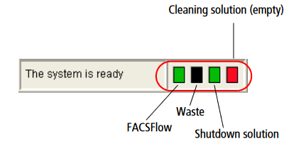

    - Sheath fluid (FACSFlow): if insufficient, replace the carton (stock under the desk) and leave the almost empty carton next to it in order to transfer the remaining sheath fluid into the new one as soon as there's spacein it (use the funnel to transfer sheat fluid).
    - Waste tank: if full, replace with an empty tank (stock at the lab entrance). Empty tank: note date; full tank: add 250ml of bleach (stock on sink) and note "+ Javel" and the date.
- Shutdown solution: if insufficient, change carton (stock under desk).
- Run Fluidics Start-up: Cytometer > Fluidics Startup > ok
- Run the sample zone fluidics washing procedure:
    - Check that there is liquid in the tubes in carousel positions 1 (FACSClean), 2 (FACSRinse) and 3 (FACSFlow).
    - Start procedure: Carousel > Clean > select 3 minutes for each tube > ok

- Lasers, detectors and choice of fluorochromes
Check that the fluorochromes you are going to use are excitable and detectable by the instrument:
- MRI website > Flow Cytometry > Our facilities > MRI-IRMB > BD FACSCanto
https://www.mri.cnrs.fr/en/flow-cytometry/our-facilities-cytometry/194-mri-irmb/irmb-equipment/10-parameters-analyzer/280-canto-becton-dickinson.html

    - Blue laser 488nm
Filter 1 (530/40): FITC, EGFP, CFSE, TO-PRO-1, Alexa 488
Filter 2 (585/42): PE, SNARF, DyeCycle Orange, Alexa 546, DiOC
Filter 3 (670 LP): PE-Cy5.5, PerCP-Cy5.5, Tri-Color, 7AAD, Alexa 700
Filter 4 (780/60): PE-Cy7, Alexa 750
    - Red laser 638 nm
Filter 5 (660/20): APC, Alexa647, Cy5, TO-PRO-3, SYTOX Red
Filter 6 (780/60): APC-Cy7, APC-Alexa 750, APC-H7
    - Violet laser 405 nm
Filter 7 (450/50): Pacific Blue, Alexa 405, PO-PRO-1, DyeCycle Violet
Filter 8 (510/50): AmCyan, SYTOX Blue, BD horizon V500, Pacific orange

- For fluorochromes not listed, use one of the spectrum viewer tools to search for excitation and emission wavelengths: Cytobase website https://cytobase.montp.inserm.fr/indexen.html > Tools to select fluorochromes
- For multiple labeling several fluorochromes are used simultaneously. In this case, it is necessary that:
-their excitation wavelengths match the light sources of the cytometer.
-their emission wavelengths are sufficiently distant so that their signals can be analyzed separately.
-the weakly expressed antigens are revealed by high yield fluorochromes and the strongly expressed antigens with low yield fluorochromes.
-in the case of co-expression on a cell, use fluorochromes with little or no overlapping spectra.
- Workspace components of FACSDiva software
When you start BD FACSDiva software, the workspace appears showing the
main application windows. Hide or show windows by clicking
buttons on the Workspace toolbar (1). Most software functions are controlled using the menu bar at the top of the workspace (2) and toolbars within the Browser (3) and Worksheet (4) windows. Acquisition and data loading is controlled using the current tube pointer (5) or buttons within the Acquisition Dashboard (6). The Status
bar (7) at the bottom of the workspace provides cytometer connection status,
fluidics information, etc

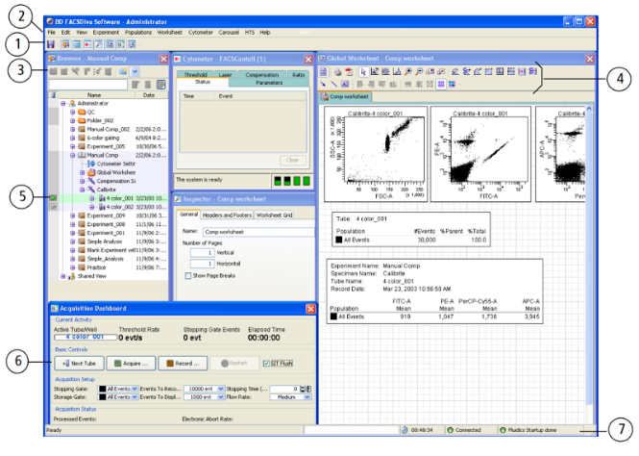

- Creating a new experiment
  - In the Users folder, create your own folder and name it with your first and last name. In your folder, click on New Experiment in the toolbar to create a new experiment. Rename it: Year-Month-Day User Name
  - Click on New Specimen to create a new specimen (e.g. Lymphocytes)
  - Click on New Tube to add tubes
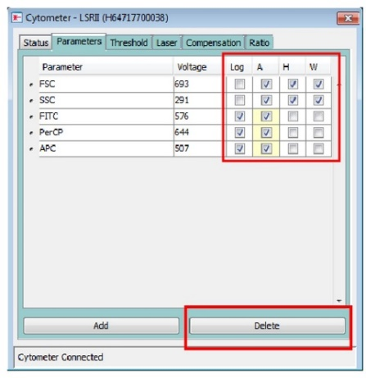
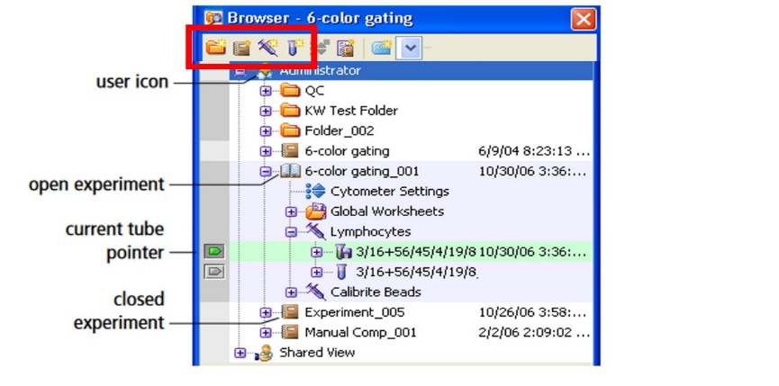

  - Select fluorochromes in Cytometer > Parameters :
    - Delete the parameters you are not interested in by selecting them and clicking on Delete (always leave SSC and FSC).
    - Click on Add and select fluorochromes from the list or, if you need to use a fluorochrome that is not present by default, put it under the corresponding detector name.
    - Activate the A (area of the collected signal profile), H (height) and W (throughput time) parameters for FSC and SSC, and the Log and A parameters for fluorescences.
    - Create the worksheet: to add a graph, click on the graph type in the workspace toolbar, then click in workspace. Next click on the axes to select the parameters to be displayed for each plot.

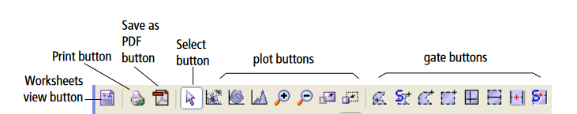

- Size/Granularity (SSC-A vs FSC-A)
- Doublets exclusion (FSC-A vs SSC-W et FSC-A vs SSC-W)
- Dot-plots : bivariate plots allowing the visualization of two optical parameters in one graph (two fluorescences or one fluorescence versus light scattering)
- Histogrammes : univariate plots allowing the visualization of one parameter versus event number.

- Set optimal voltages
Setting the voltages is an essential step in obtaining a correct compensation matrix. Voltage is optimal when: A) the positive signal is above the negative one; B) the peak of the positive signal is not off-scale (voltage too high); C) there is no loss of resolution of the positive and/or dim population (voltage too low).

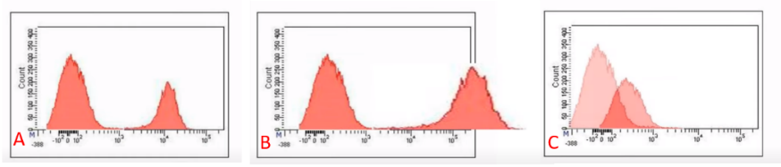

To set the voltages you need a negative control (unstained) and single-stained positive controls. The negative control is used to adjust the voltages of the SSC and FSC parameters (to correctly position the main population of interest in the FSC-A vs SSC-A dot-plot) and to fix the autofluorescence peak of the cells on each detector. The single-stained samples are then run to check that the setting made on the negative sample is correct and allows the positive peaks to be correctly visualized.
o Select the tube. Make sure that tube pointer (the little arrow to the left of the tube) is
green by clicking on the arrow .
o Place the tube of negative (unstained) cells.
o In the Acquisition Dashboard, click Acquire data
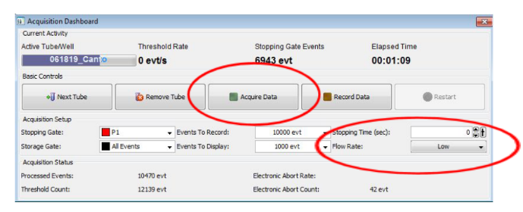

  - In Cytometer > Parameters set the SSC and FSC voltages until you see the main population of interest is around the center of the FSC-A vs SSC-A dot-plot.

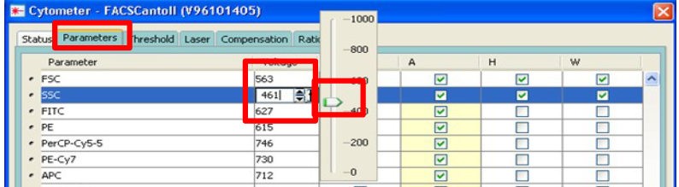

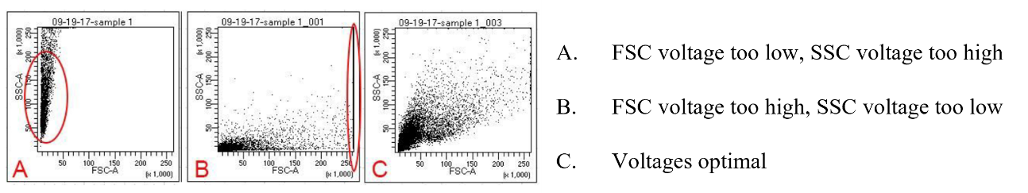

  - Create a region (gate P1) around the population of interest
  - Create the Population Hierarchy: right-click on the FSC vs SSC dot-plot > Show Population Hierarchy (this allows you to track what is being shown in each plot and you will also be able to get the % of each population)
  - Create the gates for doublets exclusion :
  - Right-click on the first dot-plot (SSC-W vs SSC-A) > Show population P1
  - Create the first region to eliminate doublets (P2)
  - Right-click on the second dot-plot (SSC-W vs FSC-A) > Show population P2
  - Create the second region to eliminate doublets (P3)
  - Show the selected cell population of interest (P3) in all the other dot-plots and histograms: select all > right-click > Show population P3
  - Set voltages for all fluorescence parameters so that negative population peaks are positioned between 0 and 10² on their corresponding channel scale
  - Record 5,000 events
  - Run stained positive controls at the same tube to check that, with the voltages set on the negative one, the positive signals are separated from the background and are not out of scale.

- Compensation

Why do we need to compensate ? https://cytobase.montp.inserm.fr/Cours/ImmunofluorescenceEN.html

Compensation is not necessary for single-color experiments. Set up for automatic- or manual- compensation for multicolor experiments. If you are using manual compensation, you can set the voltages as described in section 6 and then follow the steps described in section 7a. If you are using automatic compensation, you can set the voltages directly in the automatic compensation module, as described in section 7b. For the demonstration, we will assume this is a 3-color flow cytometric analysis experiment. These fluorochromes include FITC, PE and PerCP

7a) Manual compensation
After adjusting the voltages on the Unstained tube, run all single-stained tubes and manually correct the spectral overlap between the FITC, PE and PerCP fluorochromes.
  - Add statistics window: right-click on a dot-plot > Create Statistic View
  - Right-click on the statistics window and select Edit Statistics
  - Delete all parameters you are not interested in
  - Activate the "Median" parameter for all fluorescences in the P1 population.

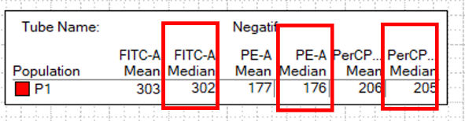

  - Note the Median values of the three fluorochromes in the P1 population.
  - Duplicate the Unstained tube on which the voltages have been set (right-click> Duplicate without data) and rename it with the name of the first single-stained tube to be run (FITC)
  - Acquire > Record
  - In Cytometer > Compensation click on Enable Compensation
  - Adjust the FITC Spectral Overlap values in PE and PerCP until you obtain the same median values (in the Statistics View window) for these two fluorochromes as for the negative one (previously noted).

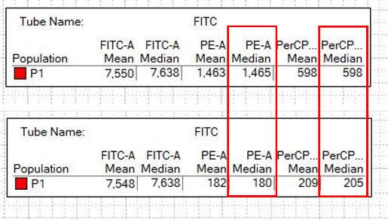
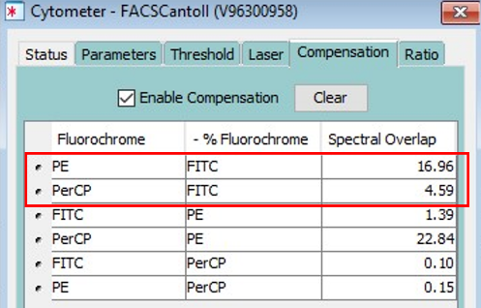

  - Duplicate the FITC tube and rename it PE
  - Acquire > Record
  - In Cytometer > Compensation adjust the PE Spectral Overlap values in FITC and PerCP until you obtain the same median values (in the Statistics View window) for these two fluorochromes as for the negative one (previously noted).

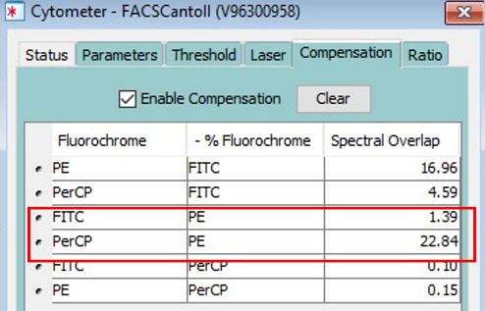
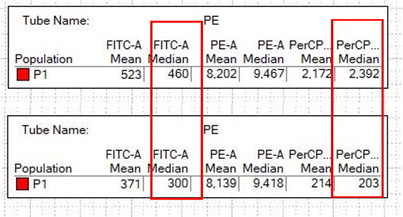

  - Duplicate the PE tube and rename it PerCP
  - Acquire > Record
  - In Cytometer > Compensation adjust the PerCP Spectral Overlap values in FITC and PE until you obtain the same median values (in the Statistics View window) for these two fluorochromes as for the negative one (previously noted).

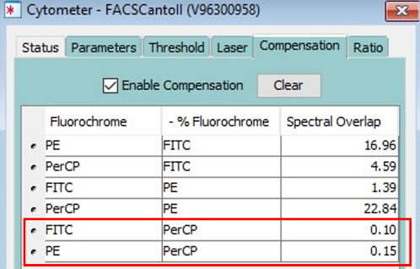
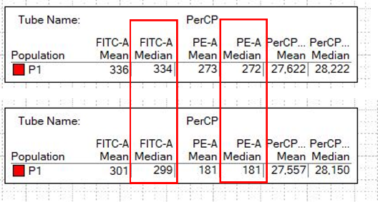

  - Run a mixture of fluorochromes to visualize the result of compensation.
  - Duplicate the PerCP tube and rename it MIX
  - Run the tube with the mixture of the three fluorochromes.
  - Observe the difference when Enable Compensation is activated or not.
7b) Automatic compensation
- Experiment > Compensation Setup > Create Compensation controls > ok.
A new specimen, named Compensation Controls with an unstained tube and tubes for single-staining, is automatically created. Also 4 worksheets are automatically created. One for the unstained with graphs for all fluorochromes and one for each single-stained with only the histogram of the corresponding fluorochrome.

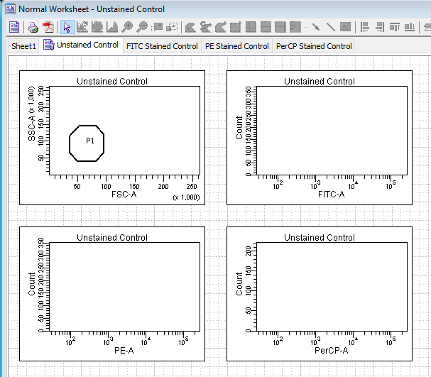
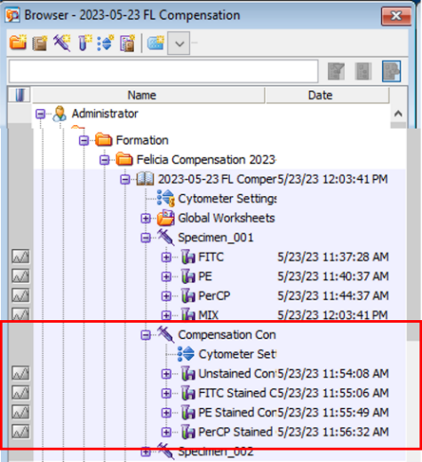

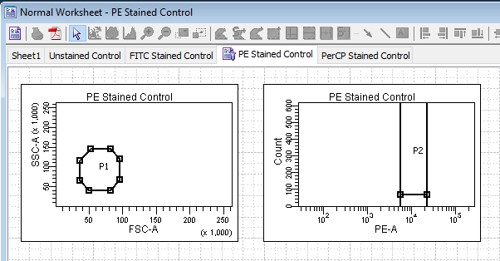
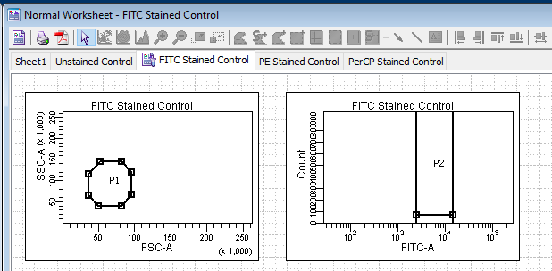

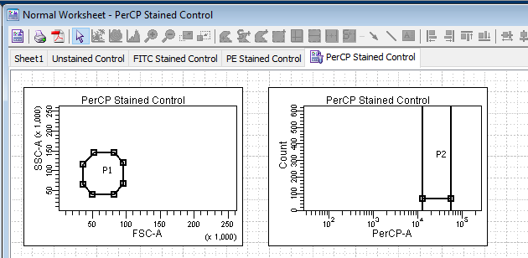

- Run the unstained tube : Acquire
- Adjust gate P1 and set voltages for all fluorescence parameters so that negative population peaks are positioned between 0 and 10² on their corresponding channel scale > Record
- Run all single-stained samples
- In the unstained tube, adjust the gate in the FSC vs SSC dot-plot and apply it to all other tubes: right-click on the gate > Apply to all compensation controls
- For each tube, adjust the gate on the positive peak in the histogram.
- Experiment > Compensation Setup > Calculate Compensation
- Apply only
- Activer Enable Compensation
- In the same Experiment, click New Spicemen to create a new series of tubes in which you will run your samples
- Click on Global Worksheet to output specific worksheets for compensation
- Run your samples.
- Export the data and make sure to take it with you
Experiment > Export > Choose Experiment or FCS File > Disque D > BD Export
  - Experiment : saves worksheets associated with the experiment, parameters and files in a folder named like the experiment.
  - FCS File: saves data files only (FCS files can be opened and analyzed in
FlowJo or other analysis software)

Important : Remember to recover your data using a USB key or external hard disk and to delete them from the analysis software and from disk D. Data will be kept for a maximum of 1 month before deletion without prior warning.

- At the end of your experiment:
Systematically check the MRI reservation website to see if another slot is reserved after yours. Leave the cytometer on standby or switch it off, depending on reservations.

9a) If there is no slot reserved after you so you are the last user for the schedule of the day:
- Perform the sample zone fluid cleaning procedure:
    - Check that there is liquid in the tubes in positions 1 (FACSClean), 2 (FACSRinse) and 3 (FACSFlow) of the Carousel.
    - Start procedure: Carousel > Clean > select 3 minutes for each tube > ok
  - Run: Cytometer > Shut-down
  - Change the waste container if it is full and fill or replace the FACSFlow and Shutdown solution cartons if it is empty or almost empty.
  - Close FACSDiva software
- Log out of your MRI session (logout icon on desktop)
- Switch off the cytometer by pressing the green main button on the left hand side.
- Leave the computer on.

9b) If there is a slot reserved after you:
- Perform the sample zone fluid cleaning procedure:
    - Check that there is liquid in the tubes in positions 1 (FACSClean), 2 (FACSRinse) and 3 (FACSFlow) of the Carousel.
    - Start procedure: Carousel > Clean > select 3 minutes for each tube > ok
  - Change the waste container if it is full and fill or replace the FACSFlow carton if it is empty or almost empty.
  - Close FACSDiva software
- Log out of your MRI session (logout icon on desktop)

To repeat the same experiment: open it and right-click > Duplicate without data. Duplicated experiments will have the voltage settings that were optimal on the day the original experiment was created. It may be necessary to adjust them.

