Starting the system

- Turn on the power to the cytometer by pressing the green main button on the left-hand side of the unit. The system power button turns on power to the cytometer, fluidics cart, and lasers (the computer must remain switched on).
- Log in to MRI with login and password (each user member of a team must have their own MRI account), select the account for billing > click ok
- Start the software BD Diva and wait for cytometer to connect
- Check fluid levels: a low fluid level or a full waste container is indicated in red.

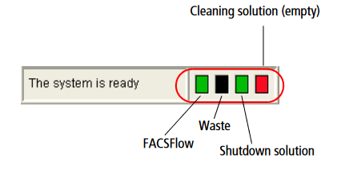

    - Sheath fluid (FACSFlow): if insufficient, replace the carton (stock under the desk) and leave the almost empty carton next to it in order to transfer the remaining sheath fluid into the new one as soon as there's spacein it (use the funnel to transfer sheat fluid).
    - Waste tank: if full, replace with an empty tank (stock at the lab entrance). Empty tank: note date; full tank: add 250ml of bleach (stock on sink) and note "+ Javel" and the date.
- Shutdown solution: if insufficient, change carton (stock under desk).
- Run Fluidics Start-up: Cytometer > Fluidics Startup > ok
- Run the sample zone fluidics washing procedure:
    - Check that there is liquid in the tubes in carousel positions 1 (FACSClean), 2 (FACSRinse) and 3 (FACSFlow).
    - Start procedure: Carousel > Clean > select 3 minutes for each tube > ok

Export the data and make sure to take it with you
Experiment > Export > Choose Experiment or FCS File > Disque D > BD Export

Important : Remember to recover your data using a USB key or external hard disk and to delete them from the analysis software and from disk D. Data will be kept for a maximum of 1 month before deletion without prior warning.

At the end of your experiment:
Systematically check the MRI reservation website to see if another slot is reserved after yours. Leave the cytometer on standby or switch it off, depending on reservations.

If there is no slot reserved after you so you are the last user for the schedule of the day:
- Perform the sample zone fluid cleaning procedure:
    - Check that there is liquid in the tubes in positions 1 (FACSClean), 2 (FACSRinse) and 3 (FACSFlow) of the Carousel.
    - Start procedure: Carousel > Clean > select 3 minutes for each tube > ok
  - Run: Cytometer > Shut-down
  - Change the waste container if it is full and fill or replace the FACSFlow and Shutdown solution cartons if it is empty or almost empty.
  - Close FACSDiva software
- Log out of your MRI session (logout icon on desktop)
- Switch off the cytometer by pressing the green main button on the left hand side.
- Leave the computer on.
If a slot is reserved after you :
- Perform the sample zone fluid cleaning procedure:
    - Check that there is liquid in the tubes in positions 1 (FACSClean), 2 (FACSRinse) and 3 (FACSFlow) of the Carousel.
    - Start procedure: Carousel > Clean > select 3 minutes for each tube > ok
  - Change the waste container if it is full and fill or replace the FACSFlow carton if it is empty or almost empty.
  - Close FACSDiva software
- Log out of your MRI session (logout icon on desktop)

